Lecture 7: The Object Class
- The Object class is the main class from which all other classes are derived.
- Any and every kind of object in Smalltalk can respond to the messages defined by the Object class
- All methods of the Object class are inherited to overridden

Functionality of an object
- Determined by its class
- Two ways to test functionality
- Comparing object to a class or superclass to test membership or composition
- receiver isKindOf: aClass
- tests if the receiver is a member of the hierarchy of aClass
- anInteger isKindOf: Integer returns true
- receiver isMemberOf: aClass
- tests if the receiver is of the same class
- anInteger isMemberOf: Magnitude returns false
- receiver respondsTo: aSymbol
- tests if the receiver knows how to answer aSymbol
- anInteger respondsTo: #sin returns true
- anInteger respondsTo: #at: returns false
- Querying the object for its class
- receiver class
- #(1 2 3) class returns Array

Comparison of objects
- Comparison and equivalence are very similar, but should not be confused
- == is used to test if the receiver and argument are the same object
- #(a b c) class == Array returns true
- #(a b c) == #(a b c) copy returns false
- = is used to test if the receiver and argument represent the same component
- #(a b c) class = Array returns true
- #(a b c) = #(a b c) copy returns true
- Other comparison operations
- receiver ~= anObject
- Not equal
- receiver ~~ anObject
- Not Equivalent
- receiver hash
- hash provides a nice way of telling objects apart, too much trust should not be placed in comparing objects of the same class, as hash is often trivialized (as in the example below, Array uses size has the hash function).
- Ex:
a := 3.147 hash. ← 132
b := 3.14 hash. ← 287
c := #(1 2 3) ← 3
d: = #(3 4 5) ← 3
- receiver hashMappedBy: map

Copying objects
- deepCopy has been removed since VisualWorks 1.0
- Two methods for copying:
- copy returns another instance just like the receiver. Usually copy is simply a shallow copy, but some classes override it.
- Does not copy the objects that the instance variables contain, but ciopies the “pointer” to the objects.
- shallowCopy returns a copy of the receiver which shares the receiver’s instance variables. This allows two objects to share one set of instance variables.

- deepCopy must be implemented in the rare cases in which it is needed
- How should this be done? Create new instances of the member objects, then assign them to the new object.
- Example, shallow copies of arrays.:

| array1 array2 object1 object2 object3|
object1 := #('A').
object2 := #('B').
object3 := #('C').
array1 := Array with: object1 with: object2 with: object3.
array2 := array1 copy.
(array1 at: 1) at: 1 put: 'D'.
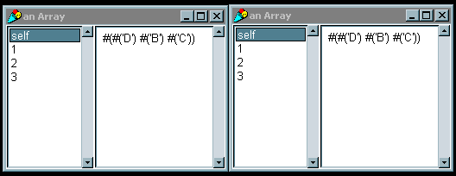array1 inspect.
array2 inspect.

Accessing indexed variables
- at: index returns the object at index
- #(a b c) at: 2 returns ‘b’
- at: index put: anObject puts anObject at index of the receiver
- returns anObject
- #(a b c) at: 4 put: #d returns ‘d’
- basicAt: index is the same as at: index but cannot be overridden
- basicAt: index put: anObject – Same as above
- size returns the number of index in the receiver
- #(a b c d) size returns 4
- basicSize same as size, but cannot be overriden
- readFromString: aString creates an object based on the contents of aString
- Yourself returns the receiver

Lecture 8: Messages & Methods
- Messages are what is passed between objects
- Methods are what is defined in a class to act on an instance of the class

Message Expressions
- Receiver-object message-selector arguments
- Unary
- Receiver message-selector
- Parsed left to right
- Ex: Time now.
- Ex: 8 squared.
- Binary
- Receiver message argument
- Parsed left to right
- Ex: 1 + 2 * 3. (Note: returns 9)
- Parenthesis do the expected
- Ex: 1 + (2 * 3). (returns 7)
- Keyword
- Receiver message arguments
- Ex:
aString = ‘ABC’.
aString at: 3 put: $D. (Note: returns ‘D’, aString equals #(ABD))
- Important to note that ‘ABC’ at: 3 put: $D returns $D
- aString is the object
- at is the keyword message-selector
- 3 is the argument
- ‘C’ is the object
- put is the keyword message-selector
- $D is the argument ($D is a literal)
- Parentheses change order
- Precedence always left to right
- Separated by periods, unless temp variable declaration or comment

Method Lookup
- A method and a message-selector must be exactly the same, or no method will be found by the method lookup
- The methods defined for the receiver’s class first
- If no match, the superclass is searched
- Path continues through Object unless a method is found.
- self refers to receiver, lookup starts within the class of the reciever
- super refers to receiver, lookup starts in superclass of receiver
- Example
- What is the order of initialization? (v1, v2, v3, v4, v5, v6)
- Why? (initialize()’s look to superclass, then return to call their own initialize because they are implemented as super initialize)

Lecture 9: Variables and Return values
- A variable is a reference to any kind of object

Method arguments
- Accessibility: private
- Scope: statements within the method
- Extent: life of the method
- Declaration: define with method name on first line of method (name: aString)
- Assignment: Assigned by sender of the message (aNode name: ‘Node2’)
- Accessing : Directly by name
- Ex: anInteger raisedToInteger: 4.
- To understand this, it is easiest to look at literals and constants used as method arguments. The argument 4 is only visible to the object and the method- it cannot be accessed outside of the method. This coincides with the life of the variable, as it dies after the method call.

Temp variables
- Accessibility: private
- Scope: statements within the method
- Extent: life of the method
- Declaration: use vertical bars
- Assignment: use ‘gets’ operator
- Accessing : Directly by name
- Example:

cubeWithInteger
| x |
x = self raisedToInteger: 3.

- x is created in the method using the vertical bars, and is released once the method is finished.

Instance variables
- Accessibility: private
- Scope: Instance methods of the defining class & subclasses
- Extent: life of the instance
- Declaration: define on the instance side of the class template

Object subclass #Node
InstanceVariableNames: ‘name nextNode’
ClassVariableName: ‘’
PoolDictionaries:’’
Category: ‘’

- Assignment: write a method that sets the value
- Accessing : write a method that gets the value
- Can be either named or keyed
- If keyed, then they can be accessed through ordinary at:put: messages

Class instance variables
- Accessibility: private
- Scope: Class methods of the defining class & subclasses
- Extent: life of the defining class
- Declaration: define on the class side of the class template

Account class
InstanceVaraibleNames: ‘interestRate’

- Assignment: write a class initialize method in the defining class and all of its subclasses
- Accessing : Write a class method that returns the value

Class Variables
- Accessibility: shared
- Scope: Instance and class methods of the defining class & subclasses
- Extent: life of the defining class
- Declaration: define on the instance side of the class template
- Assignment: write a class initialize method
- Accessing : Write a class method that returns the value
- Always begin with uppercase

Global Variables
- Accessibility: shared
- Scope: all objects, all methods
- Extent: while in Smalltalk dictionary
- Declaration: with assignment
- Assignment: with declaration
Smalltalk at: #MyTranscript put: TextCollector new.
- Accessing : Directly by name
- Don’t use, unless absolutely necessary. Bloated images, anti-OO code, incorrect code are the consequences.

Return Values
- Method always returns an object
- Default return value is self.
- Use ^ to explicitly return a different object
- Can use both implicit and explicit returns in a method (i.e. in a conditional)

Lecture 10: Blocks and Branching

Blocks
- Contains a deferred sequence of expressions
- Used in many of the control structures
- Instance of BlockClosure
- Returns the result of the last expression (similar to lisp)
- Ex: [3+4. 5*5. 20-10] returns a Home Context with value of 10.
- [3+4. 5*5, 20-10] value returns 10.
- Ex: [‘Visual’,’Works’] value returns ‘VisualWorks’ (comma is binary method)
- Syntax
[:arg1 :arg2 … :arg255 | |temp vars| executable expressions]
- A block can contain:
- 0 to 255 arguments
- temp variables
- executable expressions
- Block with no arguments: sequence of actions takes place every time value message is received by the block
- Block with arguments: action takes place every time block receives messages value, value: value, etc.
- block variables scope is only within defining block
- NOTE: temp variables inside declared blocks have not been successfully tested with Smalltalk Express or GNU Smalltalk.
- Examples
- [ :x :y | x + y / 2 ] value: 10 value: 20 (returns 15)
- [ |x| x := Date today. x day ] value (returns the day to today’s Date)
- [Date today day ] value returns same value & is more succinct
- [ :y | |x| x := y *2. x * x ] value: 5 (returns 100)
- #(5 10 15) collect: [ :x | x squared] (returns #(25 100 255)
- sends 1 argument 3 times and collects the results into an array

Class Boolean
- Classes True and False are subclasses of Boolean
- Logical operators can be used for testing
- The ‘and’ operator: &
- The ‘or’ operator: |
- The negation operator: not
- not is a unary operator
- The equivalence operator: eqv
- The exclusive or operator: xor
- The Boolean classes are used in branching
- and: and or: methods used with alternative blocks returns values of alternative blocks
- ifTrue: and ifFalse are used with blocks to provide if-then support
- can be used together in either order, or separately

Branching (Control Structures)
- Boolean classes True and False understand keyword messages:
- ifTrue:
- Ex: (result: anArray = #(‘a’ ‘b’ ‘c’))

| anArray |
anArray := #(‘a’ ‘b’ ‘d’).
(anArray at: 3) asString > ‘c’
ifTrue: [anArray at: 3 put ‘c’].

- ifFalse:
- ifTrue: ifFalse:
- Ex: (result: upperArray = #(‘A’ ‘B’ ‘D’))

| anArray upperArray |
anArray := #(‘a’ ‘B’ ‘d’).
upperArray := Array new.
upperArray := anArray collect:
[:aString | aString asUpperCase = aString
ifTrue: [aString]
ifFalse: [aString asUpperCase]].

- ifFalse: ifTrue:
- These messages demand zero argument blocks as their arguments
- Ex:
abs
^self < 0
ifTrue: [0 – self]
ifFalse: [self]
- What happens here?
- self is compared to 0
- corresponding block is executed
- (-self) or self is returned depending on which block was executed
- Repetition
- timesRepeat: message
- Ex: 5 timesRepeat [ Transcript show: ‘This is a test’; cr ]
- to: message (similar to for loop)
- Ex: 1 to: 15 by: 3 do: [:item | Transcript show: item printString; cr]
- Conditional Iteration
- Blocks can be used as arguments in messages and can be receiver objects
- whileTrue: and whileFalse: messages
- get sent to blocks. ifTrue: and ifFalse: get sent to Boolean
- Ex (receiver):

Initialize: myArray
| index |
index := 1.
[ index <= myArray size]
whileTrue:
[myArray at: index put: 0.
index := index + 1]

- Ex (argument):

Initialize: myArray
| index |
index := 1.
[ myArray at: index put: 0.
index := index + 1.
index <= myArray size] whileTrue;

Lecture 11: Reporting Errors and Debugging techniques

Error Handling
- Smalltalk’s interpreter handles all errors
- An error is reported by an object sending the interpreter the message doesNotUnderstand: aMessage
- There are some common error messages supported in the Object class, but implementation is dependant on the system
- doesNotUnderstand: aMessage
- Lets look at an example of trying to use a method that an object of the class SmallInteger cannot understand.

| anInteger |
anInteger := 0.
self doesNotUnderstand: (anInteger do:[]).
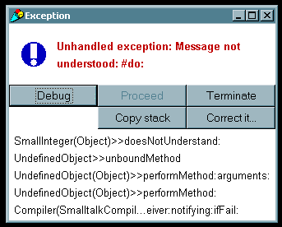
- error: aString uses aString in the report the user sees

self error: 'an Error occurred'.

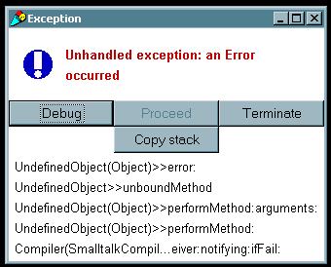
- primitiveFailed reports that a method implementing a system primitive failed
- shouldNotImplement reports that the superclass says a method should be implemented in the subclasses, the subclasses do not handle it correctly.
- This method is utilized throughout the collection classes. If we look at the Array class, we’ll see this method is used inside the add: method.
- Arrays are statically sized collections, and the add: method is used to grow the size of collections.
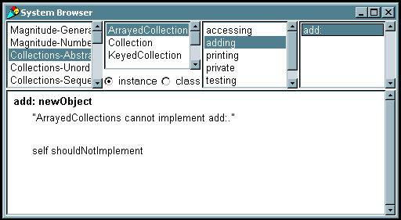
- subclassResponsibility reports that a subclass should have implemented the method
- This method is used extensively in abstract classes. This method allows all objects in the hierarchy to implement a method differently, while reporting an error if the method was not defined.
- Example: Class Auto defines a method drive, but only calls the subclassResponsibility method. We define a subclass Truck, but do not define the method drive. If we then define a Truck object and call the drive method, then Smalltalk will try to pass the drive message up the tree until a parent class knows how to implement it- in this case displaying a subclassResponsibility error message.

Object subclass: #Auto
instanceVariableNames: 'speed '
classVariableNames: ''
poolDictionaries: ''
category: 'Examples-General'!

!Auto methodsFor: 'creation'!

withSpeed: aSpeed

self subclassResponsibility! !

!Auto methodsFor: 'driving'!

accelerate

speed := speed + 1.!

decelerate

speed := speed + 1.!

drive

self subclassResponsibility! !

Auto subclass: #Truck
instanceVariableNames: ''
classVariableNames: ''
poolDictionaries: ''
category: 'Examples-General'!

!Truck methodsFor: 'creation'!

withSpeed: aSpeed

speed := aSpeed.! !

| aTruck |
aTruck := (Truck new) withSpeed: 5.
aTruck drive.

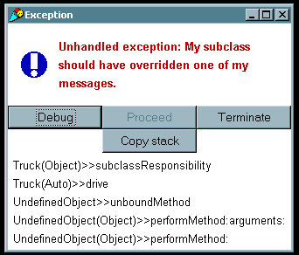

Message Handling
- Used to send messages to objects, usually only created when an error occurs
- perform: is the method called to pass messages, takes many different arguments, or just aSymbol.
- A good example of this can be seen in the Goldberg book (page 245).
- Suppose we wish to write a simple calculator that checks to make sure each operator is a valid operator.

Object subclass: Calculator
instanceVariableNames: 'result operand'
classVariableNames: ''
poolDictionaries: ''
category: 'Examples-General'!

!Calculator methodsFor: 'creation'!

new
^super new initialize

!Calculator methodsFor: 'accessing'!

result
^result

!Calculator methodsFor: 'calculating'!

apply: operator
(result respondsTo: operator )
ifFalse: [self error: ‘operation not understood’].
operand isNil
ifTrue: [result := result perform: operator]
ifFalse:
[result := result perform: operator with: operand]

clear
operand isNil
ifTrue: [result := 0]
ifFalse: [operand := nil]

operand: aNumber
operand := aNumber

!Calculator methodsFor: 'private'!

initialize
result := 0

- The following code shows an example of how to use the class Calculator

| aCalculator |
aCalculator := Calculator new. “result = 0”
aCalculator operand: 3.
aCalculator apply: #+. “result = result + 3 ← 3”
aCalculator apply: #squared. “result = 3 ^ 2 ← 9”
aCalculator operand: 4.
aCalculator apply: #-. “result = result – 4 ← 5”

- System Primitive Messages
- Messages in class Object used to support system implementation
- InstVarAt: anInteger and instVarAt: anInteger put: anObject are examples which are used to retrieve and store instance variables.
- In general, these will not be used, but are important to how Smalltalk works.

Class UndefinedObject
- the object nil represents a value for uninitialized variables
- nil also represents meaningless results
- Testing an object’s initialization is done through isNil and notNil messages

Debugging
- Smalltalk has a small set of methods for error handling and are useful to debugging. These messages are implemented by passing Signals.
- Whats a signal? A signal is an Exception passed to the VM. A signal will stop the execution and show a window with a message and has several qualities, such as whether or not the exception is proceedable. An example of this is the halt: aString message, which raises a haltSignal with the context of the receiver and the error message of aString.
- errorSignal
- messageNotUnderstoodSignal
- haltSignal
- subclassResponsibilitySignal
- confirm: similar to notify: method, brings up a window asking for confirmation, not in all implementations . In VW 3.0 and above, the confirm: method belongs to class Dialog.
- Ex: (Dialog confirm: ‘Quit ?’) ifTrue:[aBlock].

halt
- halt shows the debug window, with ‘halt encountered’ or similar message as the primary error. Useful for setting a breakpoint to check value of variables
- Ex: self halt.
- Ex: It is possible to stop other objects
Transcript halt.
- halt: aString implements halt, bringing up a window with the label from aString
- halt: appears very similar to notify:, but with one difference. halt: allows invariants related to multiple processes to be restored.
- 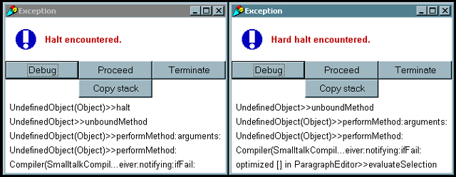How could I do this? When execution halts, use the workspace to restore the values.
- hardHalt halts the execution without passing a signal.

- notify: aString: shows a message dialog window with aString as the label. This method is not available in Smalltalk Express.
- Ex: self notify: ‘custom error message’.
- inspect displays a window showing the object and all of its variables
- Ex:
| anArray upperArray |
anArray := #(‘a’ ‘B’ ‘d’).
upperArray := Array new.
upperArray := anArray collect:
[:aString | aString asUpperCase = aString
ifTrue: [aString]
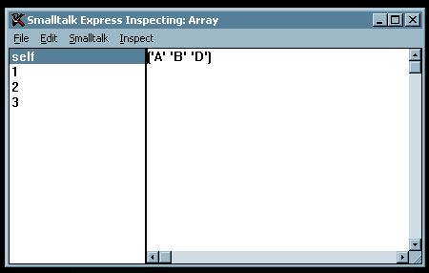 ifFalse: [aString asUpperCase]].
upperArray inspect.

Lecture 12: Designing and implementing classes

Steps to develop a specification
- Decide what we want the program to do
- Decide on the data structures
- Decide on the operations we want to apply to these data structures

The message protocol
- Class Protocol: A description of the protocol understood by a class
- Typically contains protocols for creating and initializing new instances of the class
- Instance Protocol: A description of the protocol understood by instances of a class
- Messages that may be sent to any instance of the class

Steps to implementing a class
- Deciding on a suitable representation for instances of the class.
- Selecting and implementing efficient algorithms for the methods or operations
- Deciding on class variable and instance variables

Describing a class
- Class name: A name that can be used to reference the class
- Superclass name: name of the superclass
- Class variables: variables shared by all instances
- Instance variables: variables found in all instances
- Pool dictionaries: Names of lists of shared variables that are to be accessible to the class and its instances. Can also be referenced by other unrelated classes
- Class methods: operations understood by the class
- Instance methods: operations that are understood by instances
- Example: A class for complex numbers
- Step 1: What do we want to be able to do?
- Specify real and complex parts
- Do simple operations of complex and real parts
- Step 2: What do we want to use?
- Specify real and complex parts
- Step 3: How are we going to use the data structures?
- Creating a complex number
- Accessing complex and real parts
- Adding and Multiplying Complex numbers
- The Class Description (for more detail refer to LaLonde pages 44-45)

Class Complex
Class name Complex
Superclass name Object
Instance variable names realPart imaginaryPart

Class methods

Instance creation

newWithReal: realValue andImaginary: imaginaryValue
“Returns an initialized instance”
| aComplex |
aComplex := Complex new.
aComplex realPart: realValue;
imaginaryPart: imaginaryValue.
^aComplex

accessing

realPart
“Returns the real component of the reciever”
^realPart

imaginaryPart
“Returns Imaginary part”
^imaginaryPart

operations

+ aComplex
“Returns the receiver + aComplex”
| realPartSum imaginaryPartSum |
realPartSum := realPart + aComplex realPart.
imaginaryPartSum := imaginaryPart + aComplex imaginaryPart.
^ Complex newWithReal: realPartSum andImaginary:
imaginaryPartSum.

* aComplex
“Returns the receiver * aComplex”
| realPartProduct imaginaryPartProduct |
realPartProduct := (realPart * aComplex realPart) –
(imaginaryPart * aComplex imaginaryPart).
ComplexPartProduct := (realPart * aComplex imaginaryPart) +
(imaginaryPart * aComplex realPart).
^ Complex newWithReal: realPartProduct andImaginary:
imaginaryPartProduct.

- The following code shows how to use this new class. The code computes the magnitude of the complex number. After multiplying the number by its conjugate, there is only a real part, so we just take the square root.

| aNumber |
aNumber := (Complex new) newWithReal: 1 andImaginary: 1.
aNumber := aNumber * (Complex new)
newWithReal: (aNumber realPart)
andImaginary: (0 – aNumber imaginaryPart).
(aNumber realPart) sqrt.

