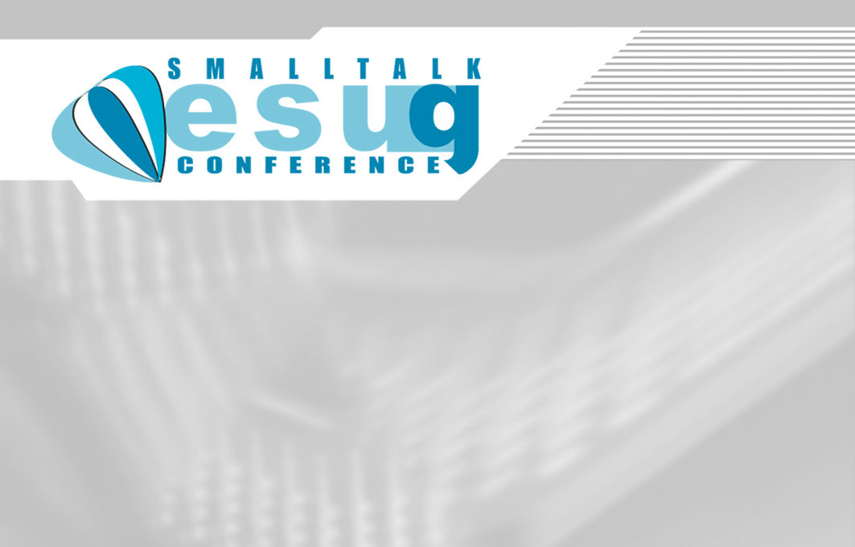  Miha Praunseis  Oria Computers d.o.o.  Slovenija | Emir Subašić  Oria Computers d.o.o.o.  Slovenijaa | Miha Praunseis  Oria Computers d.o.o.  Slovenija
Emir Subašić  Oria Computers d.o.o.o.  Slovenijaa | Miha Praunseis  Oria Computers d.o.o.  Slovenija | Emir Subašić  Oria Computers d.o.o.o.  Slovenijaa
Miha Praunseis  Oria Computers d.o.o.  Slovenija | Emir Subašić  Oria Computers d.o.o.o.  Slovenijaa | Miha Praunseis  Oria Computers d.o.o.  Slovenija

